Officer Intelligence Rating - 2

- Study the following question carefully and choose the appropriate Answer.
How many numbers amongst the numbers 9 to 54 are there which are exactly divisible by 9 but not by 3?
- 8
- 6
- 5
- none of these

- Correct the following equations by interchanging the two signs. 16+4÷2-2×7=21
- +and -
- +and ×
- - and ÷
- ÷ and ×
- None of these

- Around about description is given in the form of certain small relationships and you are required to analyse the whole chain of relation and decipher the direct relationship between the person concerned.
Introducing Asha to guests,Bhaskar said,"Her Father is the only son of my father,"How is Asha related to Bhaskar?
- Daughter
- Mother
- Sister
- Niece
- Aunt

- Following question, five words are given. Which of them will come in the middle of all if arranged alphabetically as in a dictionary?
- Conspire
- Brochure
- External
- Peaceful
- Elegance

- Following question, various terms of an alphabet series are given with one or more terms missing as shown by(?). Choose the missing terms out of the given alternatives.
ZYX-W-YZZ-XWWXY
- WXYZ
- WYXZ
- WXZY
- XYZW

- In each of the questions given below which one from the five answer figures should come at the right of the problem figures to complete the series logically

Problem Figure
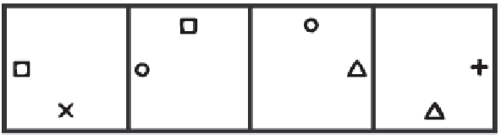

- 

- 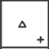

- 

- 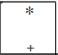

- Select a figure from amongst the Answer Figures which will continue the same series as established by the five Problem Figures.

Problem Figures:
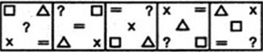

- 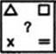

- 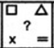

- 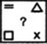

- 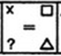

- 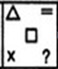

- Select a figure from amongst the Answer Figures which will continue the same series as established by the five Problem Figures.

Problem Figures:
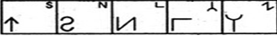

- 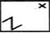

- 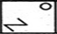

- 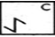

- 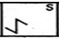

- 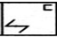

- Select a figure from amongst the Answer Figures which will continue the same series as established by the five Problem Figures.

Problem Figures:
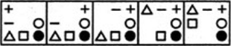

- 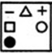

- 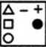

- 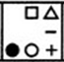

- 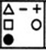

- 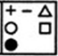

- Select a figure from amongst the Answer Figures which will continue the same series as established by the five Problem Figures.
Problem Figures:

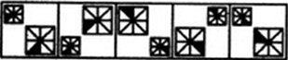

- 

- 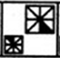

- 

- 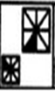

- 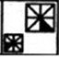

- Select a figure from amongst the Answer Figures which will continue the same series as established by the five Problem Figures.

Problem Figures:
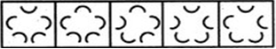

- 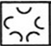

- 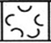

- 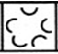

- 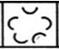

- 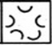

- Following questions, select a figure from given four alternatives, which when placed in the blank space (?) would complete the pattern.
Problem Figures
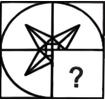

- 

- 

- 

- 

- If the following series is written in the reverse order and the alternate letter are deleted from it then which letter will divide the new series in two equal parts?
ABCDEFGHIJKLMNOPQRSTUVWXYZ
- N
- P
- L
- M
- None of these

- How many 3's are there in the following number series, which are preceded by an odd number but not followed by an even number?
3425315213673182785391345235435
- one
- two
- three
- four
- more than four

- If SPANK is coded as PSNAK then how will THROW be coded?
- HTORW
- HTWOR
- HTWRO
- HTRWO
- None of these

- The questions, group the given figures into three class using each figure only once.
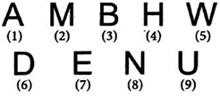
- 1,3,6; 2,8,9;4,7,5
- 1,4,8;2,5,7;3,6,9
- 1,4,7;2,5,8;3,6,9
- 1,4,7;3,5,8;2,6,9

- The following questions, a set of three figures (X), (Y) and (Z) have been given, showing a sequence in which a paper is folded and finally cut at a particular section. Below these figures a set of answer figures marked A, B, C and D showing the design which the paper actually acquires when it is unfolded are also given. You have to select the answer figure which is closest to the unfolded piece of paper.
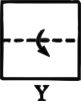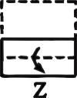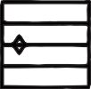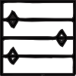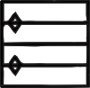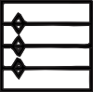
A
B
C
D

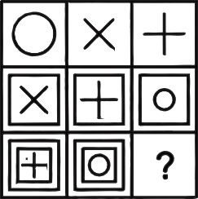
- The following questions, find out which of the answer figures (a), (b), (c) and (d) completes the figure matrix?
Problem Figures

- 

- 

- 

- 

- The following questions, choose the alternative figure in which the problem figure is embedded.
Problem Figures
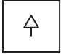

- 

- 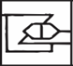

- 

- 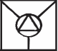

- The following problems, one figure is different in the group four. Choose the figure is different from the rest.

- 

- 

- 

- 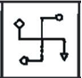

- The second figure in the first part of the problem figures bears certain relationship to the first figure. Similarly, one of the figures of answer figures bears the same relationship to the first figure of the second part. You have to select a figure from the set of answer figures which would replace the questions mark (?)
Problem figure
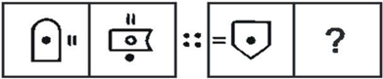

- 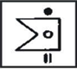

- 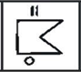

- 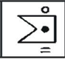

- 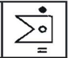

- Following problems, one figure is different in the group four. Choose the figure is different from the rest.

- 

- 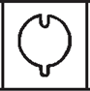

- 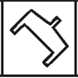

- 

- The questions, group the given figures into three class using each figure only once.
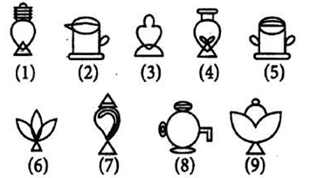

- 1, 4, 7
2, 5, 8
3, 6, 9

- 1, 4, 5
2, 6, 8
3, 7, 9

- 1, 7, 9
3, 6, 8
2, 4, 5

- 1, 6, 9
2, 5, 8
3, 4, 7

- Following question, find out which of the answer figures (1), (2), (3) and (4) completes the figure matrix?

Problem figure
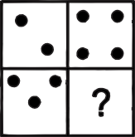
- 

- 

- 

- 

- Ruby travelled a distance of 50 km in 8 hours. She covered a part of the distance on foot at the rate of 4 km per hour and a part on a bicycle at the rate of 10 km per hour. How much distance did she travel on foot?
- 10 Km
- 20 Km
- 30 Km
- 40 Km

- Find the odd letters from the given alternatives.
- AEFJ
- KOPT
- UYZD
- EHIL

- If Rs 8.000 can maintain a family of 4 persons for 40 days, for how long will Rs 10.500 maintain a family of 6 persons?
- 30 days
- 25 days
- 35 days
- 28 days

- Arrange the following words as per the English dictionary and find the last word.
- Lean
- Leaves
- Less
- Lead

- If PALE is coded as 2134, EARTH is coded as 41590, how can is PEARL be coded in that language?
- 25430
- 29530
- 25413
- 24153

- Select the related letters from the given alternatives.
TSR : FED : : WVU ?
- CAB
- MLK
- PQS
- GFH

- If in a certain code, GLAMOUR is written as IJCNMWP and MISRULE is written a’ OGUSSNC, then how will TOPICAL be written in that code?
- VMRJECN
- VMRHAGJ
- VMRJACJ
- VNRJABJ

- A 260 metre long train runs at a speed of 55 kmph. How much time will it take to cross a platform 290 metre long?
- 20 seconds
- 18 seconds
- 36 seconds
- 60 seconds

- I go 10 m to the East, then I turn left and go 5 m, I turn left again and go 10 m and then again I turn left and go 10 m. In which direction am I from the starting point?
- East
- West
- North
- South

- If ‘light’ is called ‘morning’ , ‘morning’ is called ‘dark’ , ‘dark’ is called ‘night’ , ‘night’ is called ‘sunshine’ and ’sunshine’ is called ‘dusk’ , when do we sleep?
- Morning
- Night
- Dusk
- Sunshine

- If 64 + 7 = 460, and 25 + 8 = 212 then, 43 + 8 = ?
- 360
- 376
- 332
- 356

- Find the odd one out
- Circle : Arc
- Chair : Leg
- Glower : Petal
- Cover : Page

- Gangaram started walking towards South. After walking 15 metres he turned to the left and walked 15 metres. He again turned to his left and walked 15 metres. How far is he from his Original position and in which direction?
- 15 metres, North
- 15 metres, East
- 30 metres South
- 15 metres, West

- In a class of 60 students 45 play cricket, 30 play football. 5 play none How many students play both the games?
- 20
- 15
- 10
- 5

- In the following question, select the number(s) from the given options for completing the given series.
96, 90, 78, ?, 36, 6
- 60
- 72
- 48
- 54

- Which one is wrong number in the given series?
7, 56, 446, 3584, 28672
- 56
- 7
- 3584
- 446

- What Bank Money, in the same way, Transport : _____
- Traffic
- Goods
- Speed
- Road

- If Rs 8.000 can maintain a family of 4 persons for 40 days, for how long will Rs 10.500 maintain a family of 6 persons?
- 30 days
- 25 days
- 35 days
- 28 days

- X works twice as fast as Y. If Y can complete a job alone in 12 days, then in how many days can X and Y together finish the job?
- 18
- 6
- 4
- 8

- Determine the order of the letters. Then from the given options select the one which will complete the given series.
Q. BADC?HGJI
- EF
- FE
- FG
- DF

- In a certain code language ‘LATE’ is written as ‘VGZO’ how will ‘SHINE’ be written is that same code?
- OGLFH
- OLGFH
- LOGFH
- OLGHF

- If S means ‘–‘ , Q means $'×'$ R means $'÷'$ and P means ‘+’ then 1P45R2Q2S4=?
- 40
- 42
- 36
- 46

- Select the correct combination of mathematical signs to replace * signs and to balance the given equation?
15*24*3*6*17
- $+÷-=$
- $+×=÷$
- $-×=+$
- $-÷+=$

- Laxman went 15 km to the West from house, then turned left and walked 20 km. He, then turned East and walked 25 km. and finally turning left covered 20 km. How far is he now from his house?
- 15 km
- 20 km
- 25 km
- 10 km

- A clock is so placed that at 12 noon its minute hand points towards North – East. In which direction does its hour hand point at 1:30 pm?
- North
- South
- East
- West

ANSWERS

- D | - C | - A | - E | - A
 |  |  |  |  | - B | - D | - C | - C | - D
- B | - C | - C | - D | - D | - D | - A | - B | - A | - C
- D | - B | - C |  | - B |  |  | - A | - D | - C

