Officer Intelligence Rating - 7

- Which of the following words are incorrectly spelt?
- Separate
- Ordnance
- Success
- None of these

Direction: Which of these words completes the sentence in the way that makes most sense?
- He avoided _________ because he was _________
- Redundant
- Indispensable
- Redundancy
- Indispensible

- Which of these is the missing word?
- Lock
- Stand
- Board
- Fob

Direction: One of Four Alternative, Choose the one which best express the meaning of given mark it in the Answer Sheet.
- ACERBIC
- Bitter
- Pleasant
- Unfamiliar
- Mild

Direction: Which of these words completes the sentence in the way that makes most sense
- Dog is canine as wolf is to ___________
- Vulpine
- Ursine
- Piscine
- Lupine

- Working together, Tom, Dick and Harry need 9 hours to paint a 400 meter long fence. Working alone, Tom could complete the task n 18 hours. Dick cannot work as fast and needs 36 hours to paint the fence by himself. If Tom and Dick take the day off, how long will it take Harry to paint the fence by himself?
- 9
- 12
- 18
- 36

- If ‘ZYXW’ is coded as ‘ABCD’ then ‘STUV’ will be coded as
- HGEF
- HFGE
- HGFE
- HEPS

- A man walks 5 km east and turns left then he walks 7 km and turns right and walk 3 km, then turns right and walks 7 km. Find the shortest distance he travelled and find the direction he is now from the starting point.
- 10
- 9
- 8
- 7

- Fill in the blanks with the most appropriate word from amongst those given below:
A young man is ________ wiser than his father
- Never
- Rarely
- Much
- Usually

- “LEAVE HIM’ is coded as ‘JCYTC FGK’, ‘CATCH URGENTLY’ is coded as?
- AXRYG SPECLRJW
- AYRAF SPECLRJW
- AXRYF SPECMRJW
- AYRAF SRDCLPJW

- Success is related to HARD WORK as FAILURE is to
- Industry
- Diligence
- Waste of time
- Laziness

- Find the missing number in the series : 8, 4, 12, 6, 18, 9, ?
- 26
- 27
- 28
- 30

- If the first four letter of the word IRRESPONSIBILITY are written n reverse order, followed by the next four written in reverse order, and so on, which letter will be twelfth in the rewritten order?
- B
- P
- T
- S.

- Three of the following groups of letter are alike in some way. Which one of them is like the other four?
- ATX
- BTC
- RSX
- NYP

- Inset the missing letter
BEH
EIM
IN?
- S
- T
- R
- Q

- Write the number of pair, the words of which do not have the same type of meaning as the others –
- Danger and Risk
- Honesty and Integrity
- Liberty and Freedom
- Joy and Pain

- There are four sisters Kadambri, Kumud, Kamayani, Kalyani, Kadambri is older than Kalyani by 5 years and Kumud is younger than she by the same number of years. Kamayani is younger than Kalyani by 5 years. If Kadambri was born in 1915, in what year was the youngest sister born?
- 1920
- 1910
- 1930
- 1925

- A man was going to the temple. He met a man with seven wives. Each wife carried a child in her arms and so men and wives and children in arms, how many were going to temple?
- 50
- 49
- 48
- 1

- A boy was supposed to meet his girl friend in the evening every Sunday. The first time she came at 4.30, the next time at 5.20, then at 6.30, then at 8.00. When did she turn up the last time after that?
- 9.50
- 10.20
- 9.30
- 9.20

- STATUTE is to SHAPE as SONG is to
- Words
- Poetry
- Tune
- Beauty

Directions: In the following questions select the figure from the choices which comes next in the series.

- 
- 

- 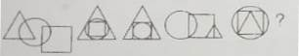
- 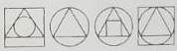

- 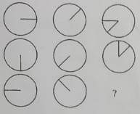
- 

- 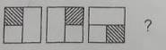
- 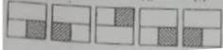

- 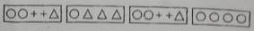

Directions – In each question below, you are given a figure (x) followed by four figures (a), (b), (c) and (d) such that (x) is embedded in one of them. Trace out the correct alternative.

- 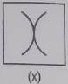
- 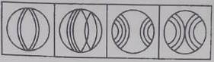

- 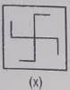
- 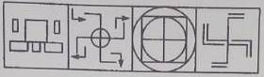

- 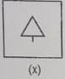
- 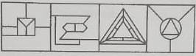

- 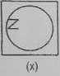
- 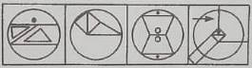

- 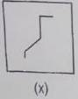
- 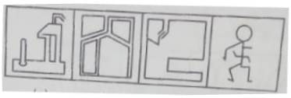

Directions – In each questions, complete the missing portion of the given pattern by selecting from the given alternatives.
- 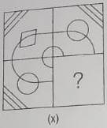
- 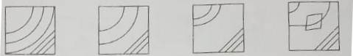

- 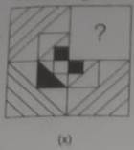
- 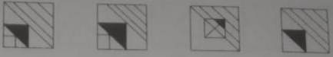

- 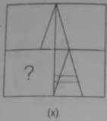
- 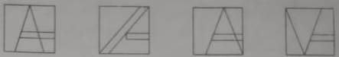

- 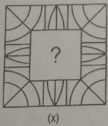
- 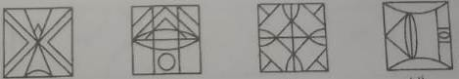

- 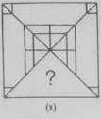
- 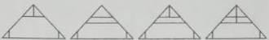

- 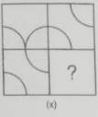
- 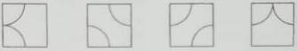

- 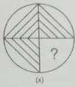
- 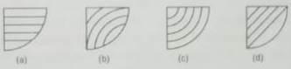

- 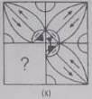
- 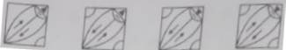

- 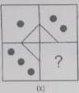
- 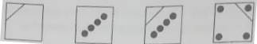

- 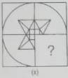
- 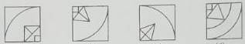

Directions: Out of the five given figures, four are similar in a certain way. One figure is not like other four. That means four figures form a group are based on some common characteristics. Find out the figure which does not belong to the group i.e. which does not share the common features/ characteristics with other four figures.
- 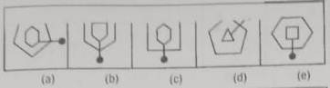

- 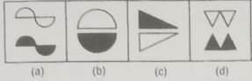

- 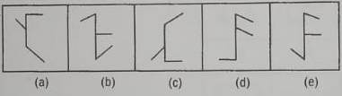

- 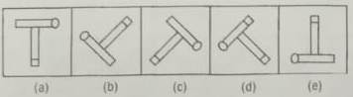

- 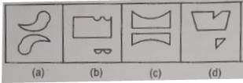

- Select the appropriate diagram representing Jama Masjid, Delhi and India?

- Which of the following diagrams best depicts cousins, nephews and males?
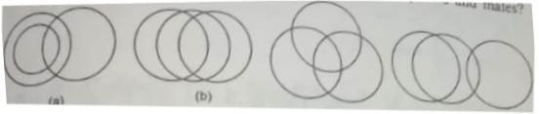
- B. C D

- Work our which of the cubes can be made from the cube net?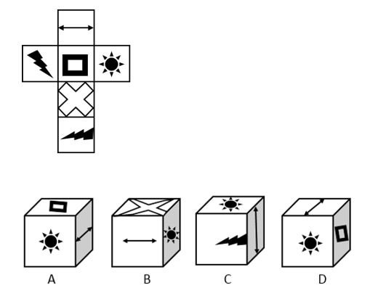

- Problem Figures
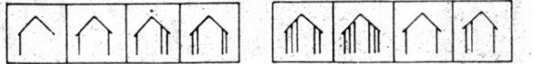
Answer Figures
- B. C. D.

- How many triangles are there in the figure given below:
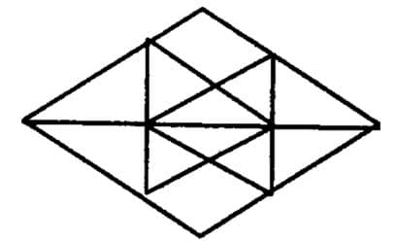
- 20
- 24
- 28
- 32

Answer Keys
1 B | 11 D | 21 D | 31 D | 41 C
2 | 12 B | 22 C | 32 C | 42 A
3 C | 13 D | 23 B | 33 | 43 D
4 A | 14 B | 24 C | 34 C | 44 D
5 D | 15 A | 25 D | 35 D | 45 C
6 D | 16 D | 26 D | 36 D | 46 B
7 C | 17 D | 27 C | 37 D | 47 D
8 C | 18 D | 28 C | 38 D | 48 A
9 B | 19 A | 29 A | 39 C | 49 A
10 D | 20 C | 30 D | 40 B | 50 C

