Officer Intelligence Rating - 3

- ORANGE is coded as ‘LOXKDB’ then GRAPES is coded as?
- DOYMBP
- DOXNBP
- DOXMBP
- DPXMBP
- DOXMBQ

- MONEY is coded as ‘Innpmodfxz’, then RUPEE is coded as?
- Qstvoqdfdf
- Qsvtoqdtdf
- Qstvqodfdf
- Qstvoqtdfd

- ‘NIGRE’ is coded as ‘ADOQC’ then ‘ENGINEER’ is coded as?
- CAODCACQ
- CADOACCQ
- CAODACQC
- CODACACQ
- CAODACCQ

- ‘LEAVE HIM’ is coded as ‘JCYTC FGK’, ‘CATCH URGENTLY’ is coded as?
- AXRYG SPECLRJW
- AYRAF SPECLRJW
- AXRYF SPECMRJW
- AYRAF SRDCLPJW
- AYRAG SPDCLRJW

- ‘DANCE’ is coded as ‘12345’ and ‘DANGER’ is coded as ‘EAGERED’ is coded as?
- 5465751
- 5275651
- 5365751
- 5265751
- 5635751

- A man walks 7 km towards south, then turns $60°$ and walks 15 km, then turns right and walks 12 km, then turns right and walks 15km, then turns left and walks 5 km. Then find the direction he is from the starting point ?
- South – East
- South
- East
- North
- West

- A girl walks 25 meters towards east, then turns right walks 45 meters and turns right and walks 25 meters right and turns right and walks 78 meters. Then find the distance she has walked from the starting point and find the direction she is from the starting point ?
- 33 m, south
- 33 m, north
- 45 m north
- 25 m, north
- 78 mm north

- A person walks 7 km towards south and turns right, walks 3 km and turns left, walks 13 km and then turns left, walks 3 km and turns right, walk 4 km and turns left, walks 4 km and then turns right, walks 6 Km and turns right, walks 4 km. Find in which direction he is from the starting point and the distance he is from the starting point.
- South, 23 km
- East, 23 Km
- South, 30 Km
- North, 23 Km
- North, 30 Km

- A man walks 4 kms towards north and turns right, walks 7 kms and turns right, walks 4 kms and turns left, walks 9 kms, turns left and walks 4 kms then turns right, walks 6 kms and turns right and walks 4 kms. Find the distance he is from the starting point and in which direction is he from the starting point?
- 20 Km, west
- 22 km, east
- 32 km, south
- 22 km, south
- 22 km, north

- A man walk 10 kms towards east, then turn 60⁰ angle left, walks 6 kms and turns right, walks 5 km and turns 30⁰ angle right and walks 4 kms. Then find in which direction he from the starting point?
- North-east
- North-west
- South-east
- South-west
- North

Direction (Q.Nos. 11- 20) in the following questions select the figure from the choices which comes next in the series

- 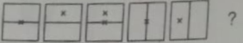
- 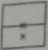

- 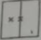

- 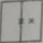

- 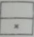

- 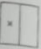

- 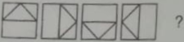
- 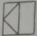

- 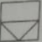

- 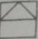

- 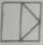

- 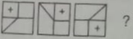
- 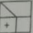
- 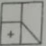
- 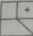
- 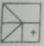

- 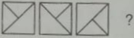
- 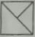
- 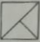
- 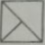
- 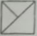

- 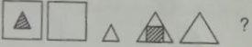
- 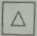
- 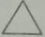
- 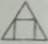

- 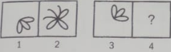
- 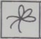
- 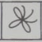
- 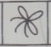
- 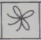
- 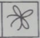

- 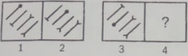
- 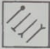
- 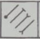
- 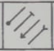
- 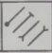
- 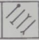

- 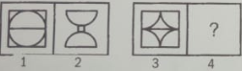
- 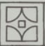
- 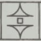
- 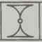
- 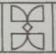
- 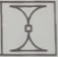

- 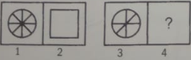
- 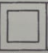
- 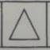
- 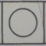
- 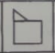
- 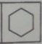

- 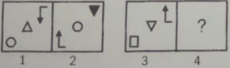
- 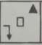
- 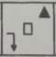
- 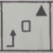
- 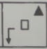

- 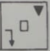

- How many squares are there in the following figure?
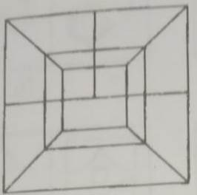
- 5
- 9
- 7
- 8
- None of these

- How many squares are there in the following figure?
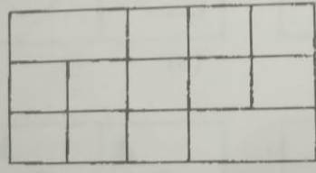
- 10
- 16
- 14
- 12
- None of these

- How many triangles are there in the following figure?
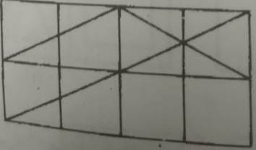
- 29
- 23
- 19
- 21
- None of these

- How many triangles are there in the following?
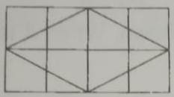
- 22
- 18
- 8
- 16
- None of these

- How many rectangles are there in the following figure?
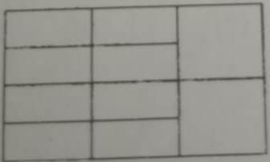
- 10
- 13
- 8
- 16
- None of these

- What will be the number at the bottom if 5 is at the top? The two positions of the dice are being given below?
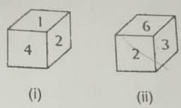

- 3
- 4
- 2
- 6
- None of these

- A dice is thrown four times and its four different positions are given below. Find the number on the face opposite the face showing 2.
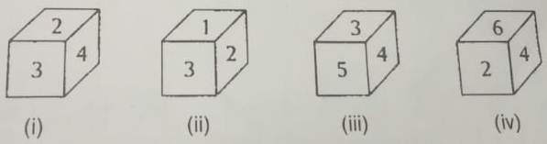

- 3
- 4
- 5
- 6
- None of these
- Two positions of a dice are shown. When 4 is at the bottom, what number will be on the top?
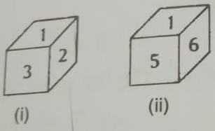
- 1
- 2
- 5
- 6
- None of these

- 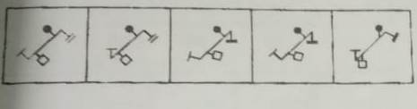
- 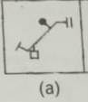
- 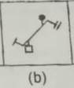
- 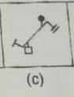
- 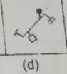
- 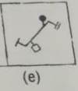

- 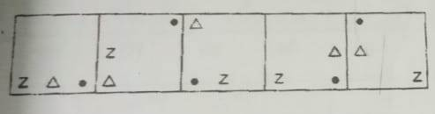

- 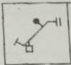
- 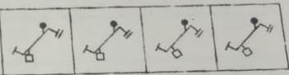

- 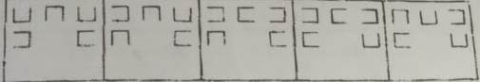
- 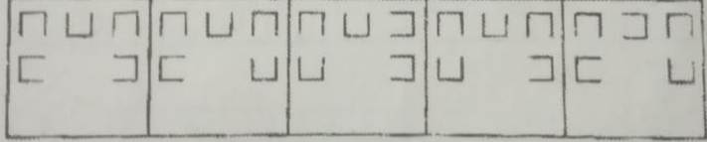

- 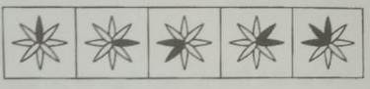
- 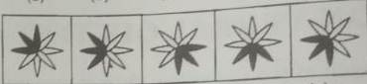

- 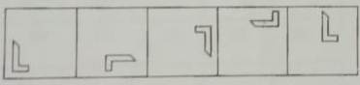
- 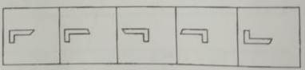

- 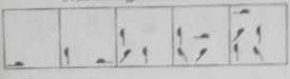
- 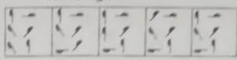
- 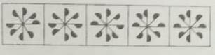
- 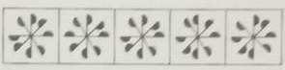

- 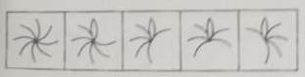
- 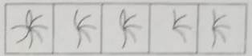

- 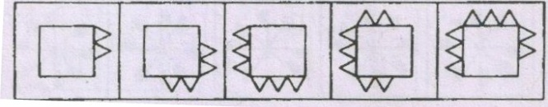

- 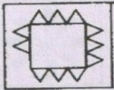
- 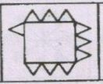
- 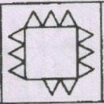
- 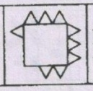
- 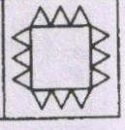

- 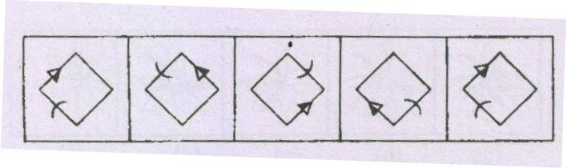
- 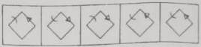

- 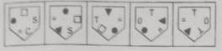
- 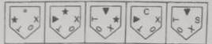

- 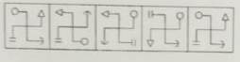
- 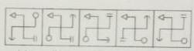

- 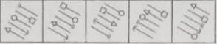
- 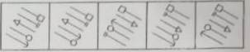

- 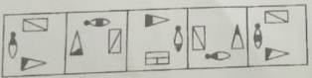
- 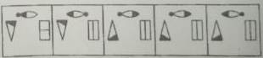

- 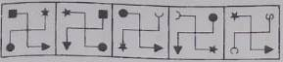
- 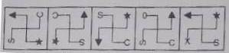

- 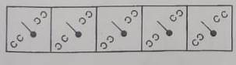
- 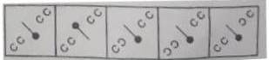

- 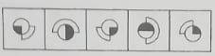
- 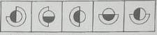

- 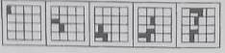
- 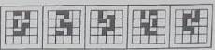

- 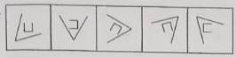
- 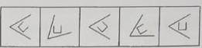

- 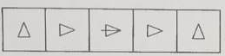
- 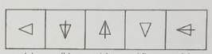

- 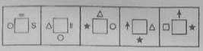
- 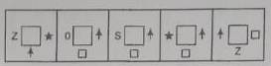

- 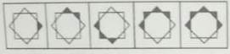

- 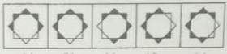

ANSWERS

- D | - C | - A | - E | - A | - A | - B | - E | - D | - B
- C | - B | - A | - C | - A | - B | - A | - A | - C | - B
- D | - C | - A | - D | - B | - B | - D | - C | - C | - D
- B | - C | - C | - D | - D | - D | - A | - B | - A | - C
- D | - B | - C | - C | - B | - B | - B | - A | - D | - C

